KICK-OFF MEETING

Joint Training and Research Programme
on
Chromatin Dynamics &
the DNA Damage Response
(Contract No 812829 – Starting Date: March 1, 2019)

Heraklion, March 20-21 2019

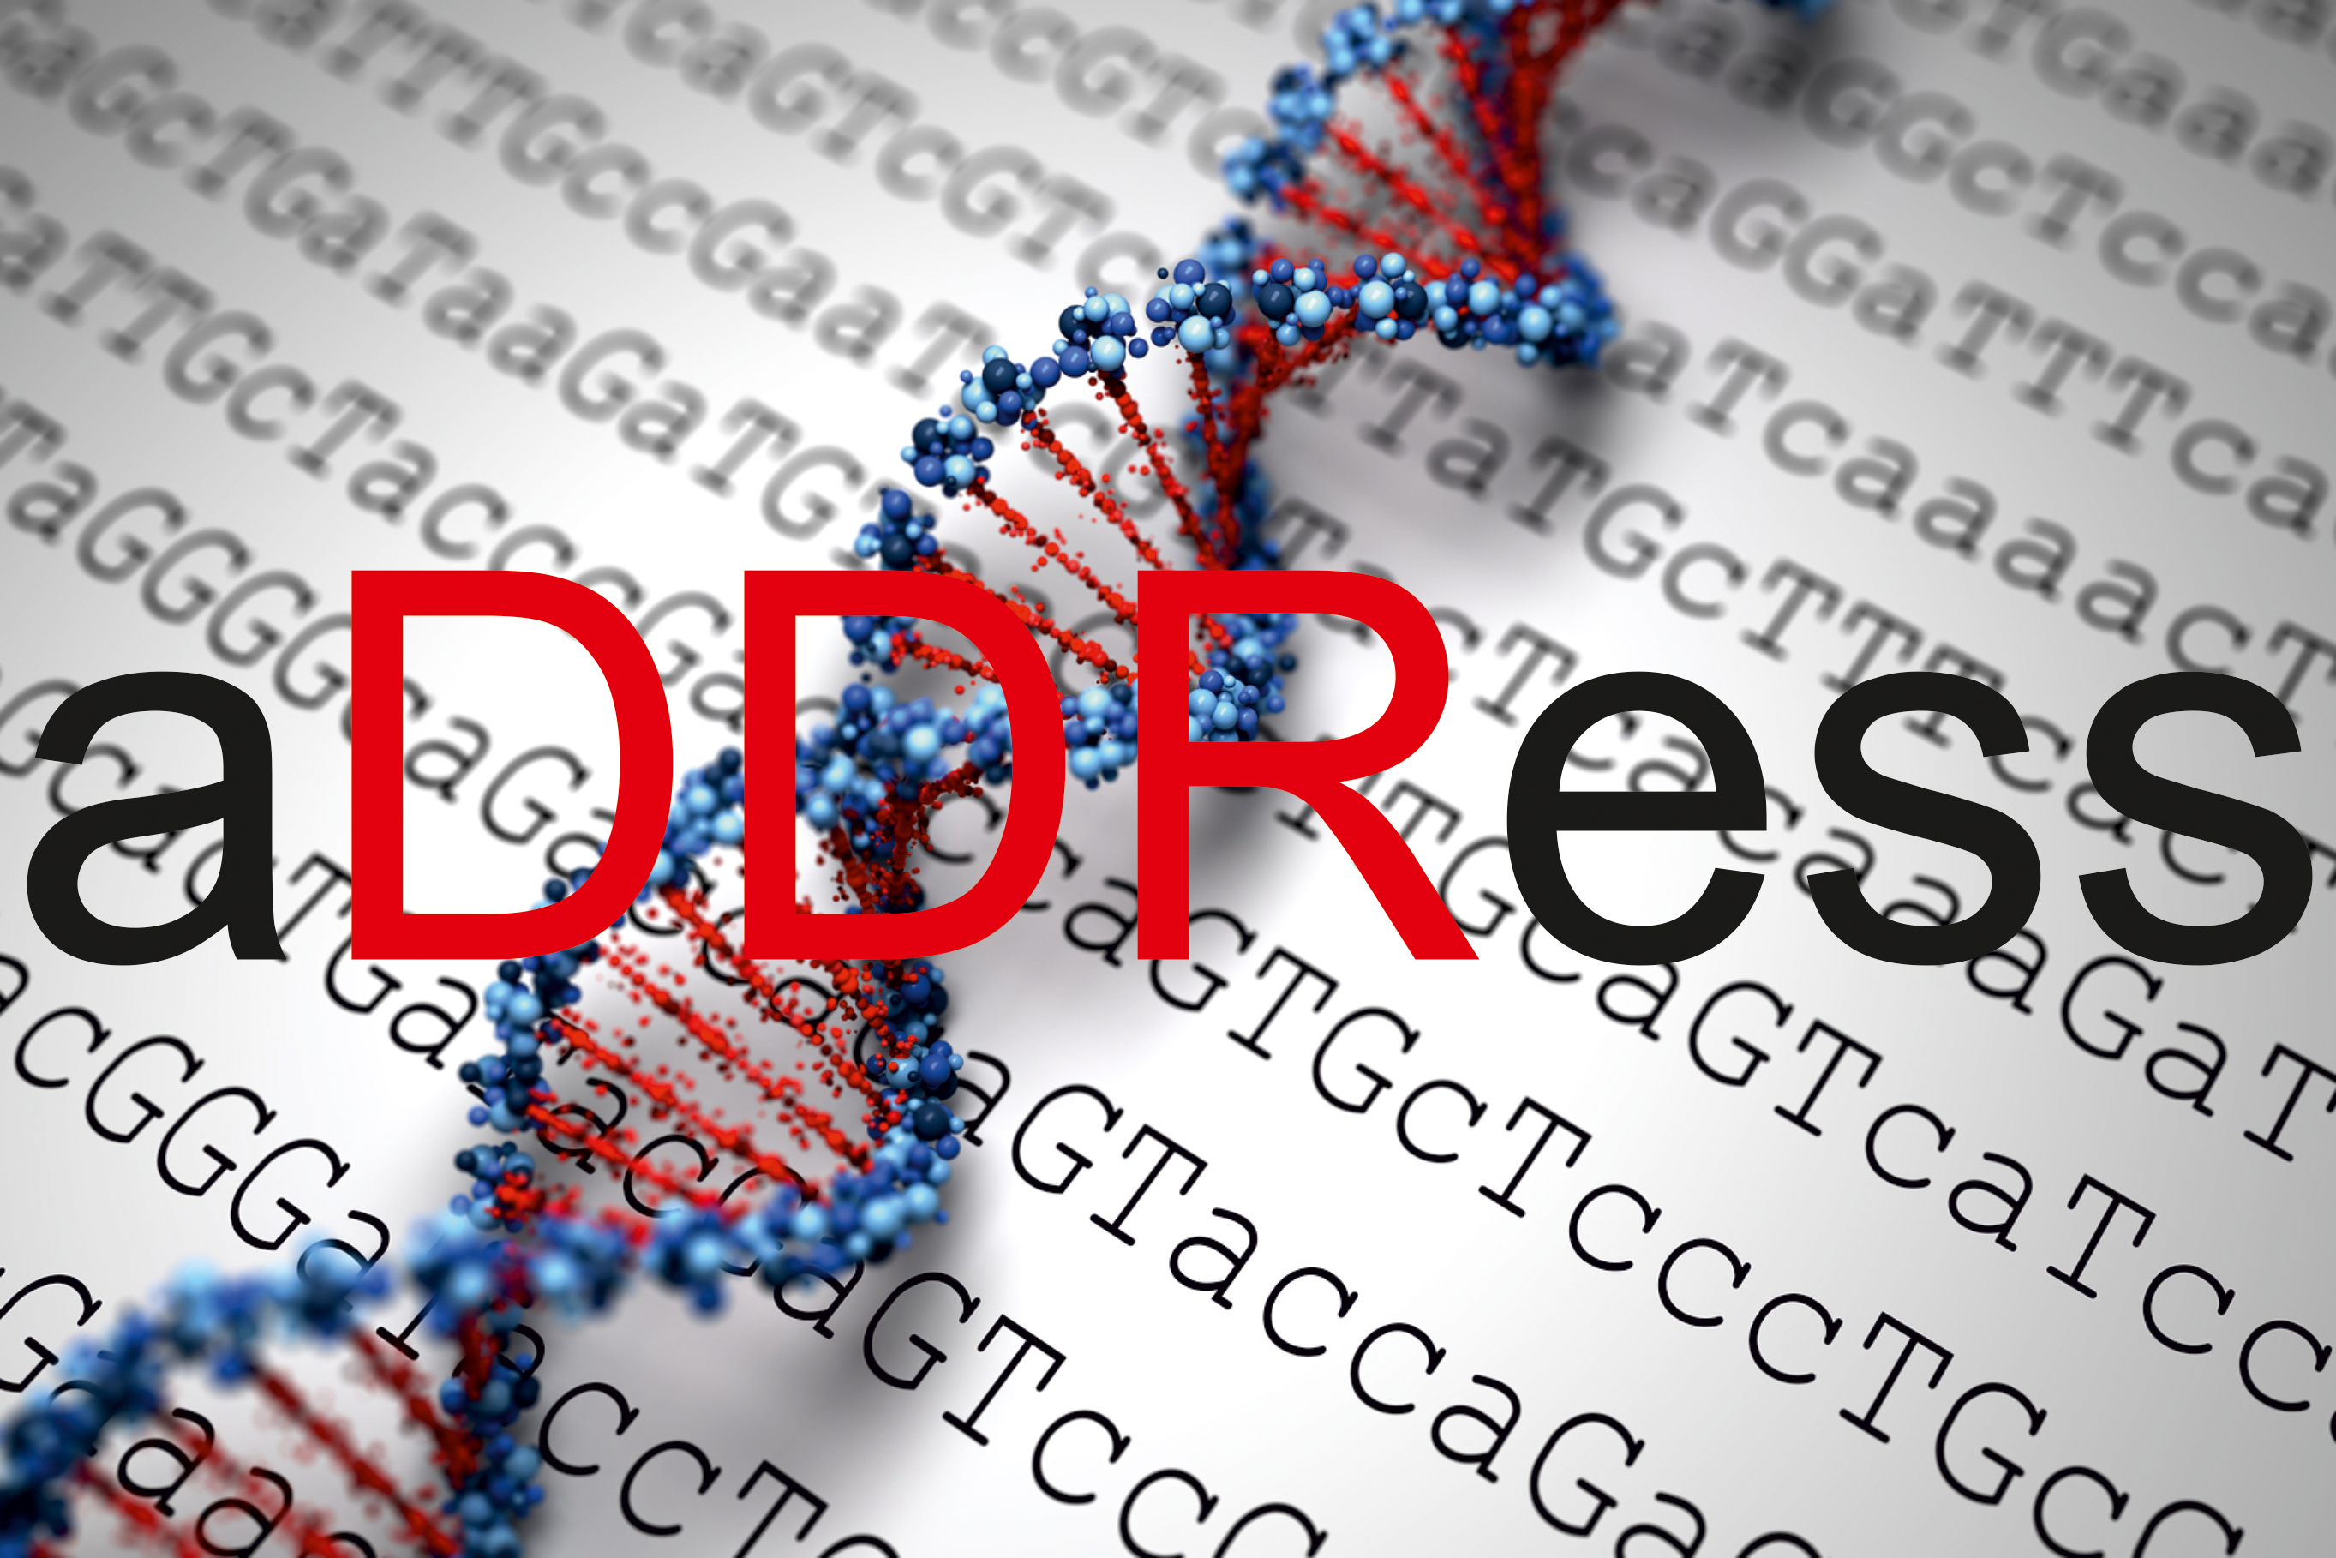

MARIE SKLODOWSKA-CURIE ACTIONS

Innovative Training Networks (ITN)
Call: H2020-MSCA-ITN-2018
Kick-off Meeting Agenda
Wednesday, March 20, 2019

19.00 Welcome dinner offered by the IMBB (“Peskesi” Restaurant)

Thursday, March 21 , 2019
09.30 Welcome to FORTH & Coffee
10.00 Management meeting: the Network and the Partners (George A. Garinis)
Partners Group & Project Presentation (15 min/group)
11.00 Dana Branzei Group, IFOM Fondazione Instituto di Oncologia Moleculare
11.15 Andreas Ladurner Group, Ludwig-Maximilians-Universitaet Muenchen
11.30 George Garinis Group, Institute of Molecular Biology and Biotechnology-FORTH
11.45 Babis Spilianakis Group, Institute of Molecular Biology and Biotechnology-FORTH
12.00 Nicola Crosetto Group, Karolinska Institutet
12.15 Jaqueline Jacobs Group, Stichting Het Nederlands Kanker Instituut-Antoni van Leeuwenhoek Ziekenhuis.
12.30 Björn Schumacher Group, Klinikum der Universitaet zu Köln
13.00 Lunch break
14.00 Joachim Lingner Group, Ecole Polytechnique Federale de Lausanne
14.15 Sophie Polo Group, Université Paris Diderot-Paris 7
14.30 Gaëlle Legube Group, Centre Nationale de la Recherche Scientifique
14.45 Coffee break
15.15 Niels Mailand Group, University of Copenhagen
15.30 Lumir Krejčí Group, Facultni Nemocnice U SV. Anny V BRNE
15.45 Sylvie Sauvaigo Group, LXRepair SAS
16.00 Andrew Collins Group, NorGenoTech AS
16.15 Matti Nykter Group, Genevia Technologies Oy
16.30 Coffee break
17.00 aDDRess Management Meeting
19.30 Dinner offered by IMBB (“Merastri” restaurant)

